Measuring GRAVITATIONAL POTENTIAL ENERGY
TASK: Measure the GPE object and how well it converts to Kinetic energy
A very simple science report has been already started for you – see below. You need to complete the report. While this task is simple, the skills you develop will be useful in later experiments. The parts you need to do are…
- make up a suitable method (see the results table for clues)
- Collect results neatly and calculate GPE and Kinetic energy
- Graph the dependant variables against the independent variable.
Aim: To measure how GPE and kinetic energy are connected.
Variables: Independent (2) = Height of the object
Dependant = Gravitational Potential Energy of the object
Controlled = _______________________________________________
Hypothesis: The higher the object, and the GPE it has, and the greater the Kinetic Energy it will have at the bottom of the ramp. This is because GPE is converted to KE as the ball rolls down the ramp.
Method: MATERIALS

- Large marble or tennis ball
- Ruler
- Stopwatch
- Metre ruler
- Electronic balance

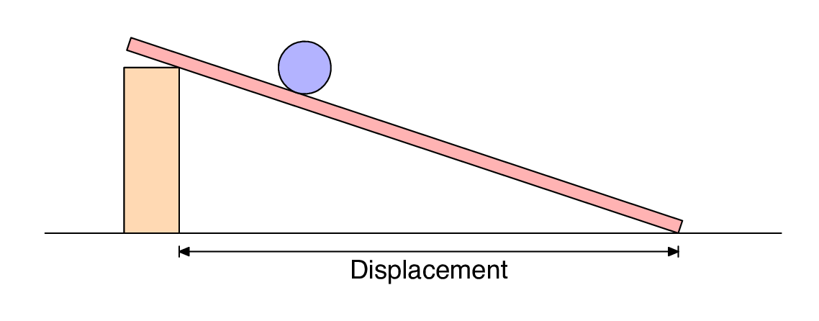
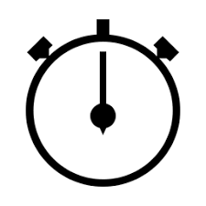
2 m
ht
METHOD:
- __________________________________________________________________
- __________________________________________________________________
- __________________________________________________________________
- __________________________________________________________________
- __________________________________________________________________
- __________________________________________________________________
- __________________________________________________________________
Results:
Table1: E_{GP} of a rolling object.
Object Height, h (in m) | Uncertainty in the Height (in m) ± | Mass, m  (in kg) | Uncertainty in the mass (in kg)  ± | E_{GP} (J)  $$GPE=m×9.8×h$$
0.10 | 0.005 | 0.0458 | 0.0000005 | 0.045
0.12 | 0.005 | 0.0458 | 0.0000005 | 0.054
0.14 | 0.005 | 0.0458 | 0.0000005 | 0.063
0.16 | 0.005 | 0.0458 | 0.0000005 | 0.072
0.18 | 0.005 | 0.0458 | 0.0000005 | 0.081

Table1: E_{K} of a rolling object.
Mass, m (in kg) | Uncertainty in the mass (in kg)  ± | Time to roll 2.0 m (seconds) |  |  |  | Uncertainty in the Avg time (in s)  ± $\frac{range}{2}$ | Velocity, v (m/s)  v = 2 / time | Kinetic Energy E_{K} (J)  KE = ½ x m x v²
 |  | Trial 1 | Trial 2 | Trial 3 | Avg
0.0458 | 0.0000005 | 2.00 | 1.97 | 1.97 | 1.98 | 0.015 | 1.01 | 0.023
0.0458 | 0.0000005 | 1.88 | 1.84 | 1.78 | 1.83 | 0.05 | 1.09 | 0.027
0.0458 | 0.0000005 | 1.71 | 1.62 | 1.66 | 1.66 | 0.045 | 1.20 | 0.033
0.0458 | 0.0000005 | 1.53 | 1.47 | 1.50 | 1.50 | 0.03 | 1.33 | 0.041
0.0458 | 0.0000005 | 1.37 | 1.28 | 1.31 | 1.32 | 0.045 | 1.52 | 0.053

Table2: Comparision of E_{GP} and E_{K} for a ball rolling down a ramp.
Calculate the efficiency of the ramp by comparing the E_{GP} and E_{K} using the table below.
E_{GP} (J)  From the table, write the E_{GP} in here again | Kinetic Energy, E_{K} (J)  From the table, write the E_{K}’s in here again | Efficiency (%)  $$Efficiency= \frac{E_{K}}{E_{GP}}×100$$ | Average Efficiency of the ramp (%)
0.045 | 0.023 | 52 | 55
0.054 | 0.027 | 51
0.063 | 0.033 | 53
0.072 | 0.041 | 57
0.081 | 0.053 | 65

Graph1: E_{K} versus the E_{GP}
E_{K} - Kinetic Energy (Joules) ((Joules(Joules)
E_{GP} – Gravitational Potential Energy (Joules)
.

